**Magnetism Level 8&9 practise questions and answers**

**Q1.**

A megaphone uses a loudspeaker to amplify sounds that are detected by a microphone.

**Figure 1** shows a megaphone and microphone.

**Figure 1**

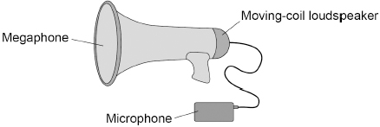

(a)  Complete the sentence.

The microphone is used to convert the pressure variations in sound waves into

variations in  ____________________.

**(1)**

(b)  The loudspeaker contains a permanent magnet.

Which diagram in **Figure 2** shows the direction of the magnetic field between the north pole and the south pole of the magnet? The magnets are shown in cross-section.

Tick (**✓**) **one** box.

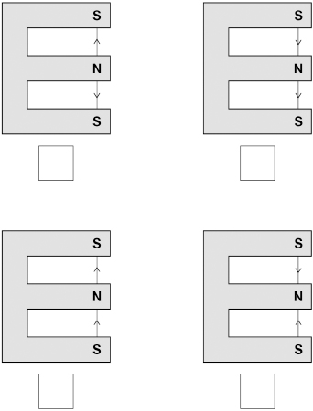

**(1)**

(c)  Some magnets are permanent magnets and some are induced magnets.

What is an induced magnet?

___________________________________________________________________

___________________________________________________________________

___________________________________________________________________

**(1)**

**Figure 3** shows the parts of the loudspeaker in the megaphone.

**Figure 3**

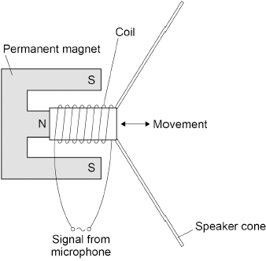

A current in the coil of the loudspeaker causes the coil to move.

(d)  What is the name of the effect that causes the coil to move?

Tick (**✓**) **one** box.

|  |  |
| --- | --- |
| Electromagnet effect |  |
| Induction effect |  |
| Motor effect |  |
| Speaker effect |  |

**(1)**

(e)  When the current in the coil is 16 mA, the force on the coil is 0.013 N.

The length of the wire that makes up the coil is 6.5 m.

Calculate the magnetic flux density around the coil in the electromagnet.

Use the Physics Equations Sheet.

___________________________________________________________________

___________________________________________________________________

___________________________________________________________________

___________________________________________________________________

___________________________________________________________________

___________________________________________________________________

___________________________________________________________________

Magnetic flux density =  ____________________ T

**(4)**

(f)   Megaphones can produce very loud sounds.

A person’s hearing can be affected by age and by working in a loud environment.

**Figure 4** shows how frequency affects the minimum sound level that can be heard by three different people, **A**, **B** and **C**.

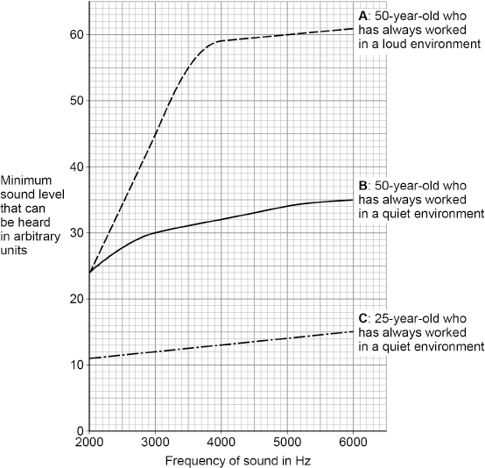

Compare how different factors affect the minimum sound level that these people can hear.

___________________________________________________________________

___________________________________________________________________

___________________________________________________________________

___________________________________________________________________

___________________________________________________________________

___________________________________________________________________

___________________________________________________________________

___________________________________________________________________

___________________________________________________________________

___________________________________________________________________

**(4)**

**(Total 12 marks)**

**Q2.**

The figure below shows a transformer used to power a lamp using the mains electricity supply.

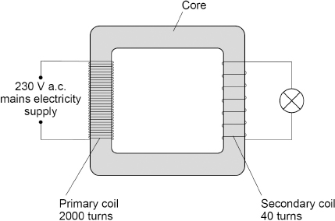

(a)  What material is used to make the core of the transformer?

Give the reason for using this material.

Material  ____________________

Reason  ____________________________________________________________

___________________________________________________________________

**(2)**

(b)  Determine the current in the secondary coil when the power output of the transformer is 6.9 W.

The transformer is 100% efficient.

Use the Physics Equations Sheet.

___________________________________________________________________

___________________________________________________________________

___________________________________________________________________

___________________________________________________________________

___________________________________________________________________

___________________________________________________________________

___________________________________________________________________

___________________________________________________________________

Current in the secondary coil =  ____________________ A

**(5)**

**(Total 7 marks)**

**Q3.**

A teacher demonstrated how a magnetic field can cause a copper rod to accelerate.

The teacher placed the copper rod on two brass rails in a magnetic field.

The copper rod was able to move. The figure below shows the equipment used.

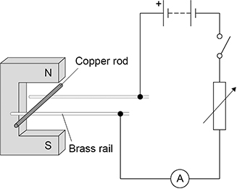

(a)  The teacher closes the switch and the copper rod accelerates.

Explain how Fleming’s left hand rule can be used to predict the direction in which the copper rod will move.

___________________________________________________________________

___________________________________________________________________

___________________________________________________________________

___________________________________________________________________

___________________________________________________________________

___________________________________________________________________

___________________________________________________________________

___________________________________________________________________

___________________________________________________________________

**(5)**

(b)  Suggest **two** changes to the equipment that would increase the force on the copper rod.

1  _________________________________________________________________

___________________________________________________________________

2  _________________________________________________________________

___________________________________________________________________

**(2)**

(c)  The teacher closed the switch and the copper rod accelerated uniformly from rest for 0.15 s.

The current in the copper rod was 1.7 A.

mass of copper rod = 4.0 g

length of copper rod in the magnetic field = 0.050 m

magnetic flux density = 0.30 T

Calculate the maximum possible velocity of the copper rod when it left the magnetic field.

___________________________________________________________________

___________________________________________________________________

___________________________________________________________________

___________________________________________________________________

___________________________________________________________________

___________________________________________________________________

___________________________________________________________________

___________________________________________________________________

___________________________________________________________________

___________________________________________________________________

___________________________________________________________________

Maximum velocity = _______________ m/s

**(6)**

**(Total 13 marks)**

**Q4.**

(a)  **Figure 1** shows a solenoid.

Draw the magnetic field of the solenoid on **Figure 1**.

**Figure 1**

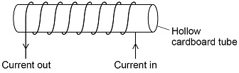

**(2)**

(b)  **Figure 2** shows two iron rods placed inside a solenoid.

**Figure 2**

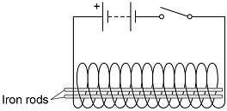

Explain why the iron rods move apart when the switch is closed.

___________________________________________________________________

___________________________________________________________________

___________________________________________________________________

___________________________________________________________________

___________________________________________________________________

**(2)**

A student investigated the strength of an electromagnet.

The student investigated how the strength depended on:

•   the current in the wire

•   the number of turns of wire around the iron core.

**Figure 3** shows the equipment used.

**Figure 3**

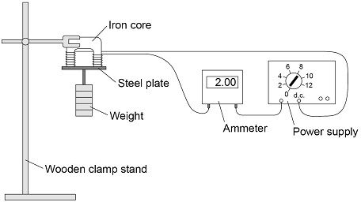

The student measured the strength of the electromagnet as the maximum weight the electromagnet could hold.

(c)  The following table shows the results.

|  |  |  |
| --- | --- | --- |
| **Current in amps** | **Number of turns of wire** | **Maximum weight in newtons** |
| 1.0 | 30 | 6.5 |
| 1.5 | 20 | 6.4 |
| 2.0 | 10 | 3.7 |

Explain why the method used by the student is **not** valid for this investigation.

___________________________________________________________________

___________________________________________________________________

___________________________________________________________________

___________________________________________________________________

___________________________________________________________________

**(2)**

A second student repeated the investigation using the same equipment.

**Figure 4** shows the second student’s results.

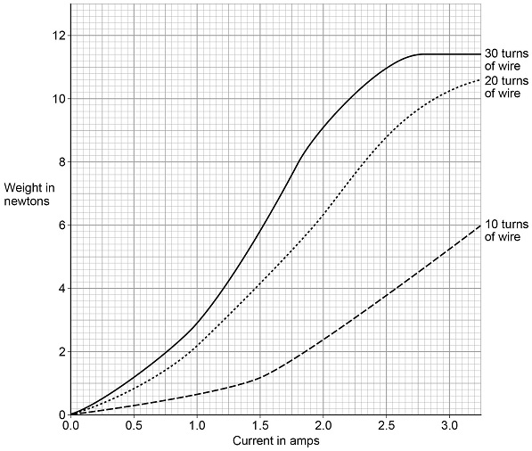

(d)  How does increasing the current in the wire affect the strength of the electromagnet, when the electromagnet has 30 turns of wire?

___________________________________________________________________

___________________________________________________________________

___________________________________________________________________

**(1)**

(e)  How does increasing the number of turns of wire from 10 to 20 affect the strength of the electromagnet, compared to increasing the number of turns of wire from 20 to 30?

___________________________________________________________________

___________________________________________________________________

___________________________________________________________________

**(1)**

**(Total 8 marks)**

**Q5.**

A student used a simple transformer to investigate how the number of turns on the secondary coil affects the potential difference (p.d.) across the secondary coil.

The student kept the p.d. across the primary coil fixed at 2V. **Figure 1** shows the results collected by the student.

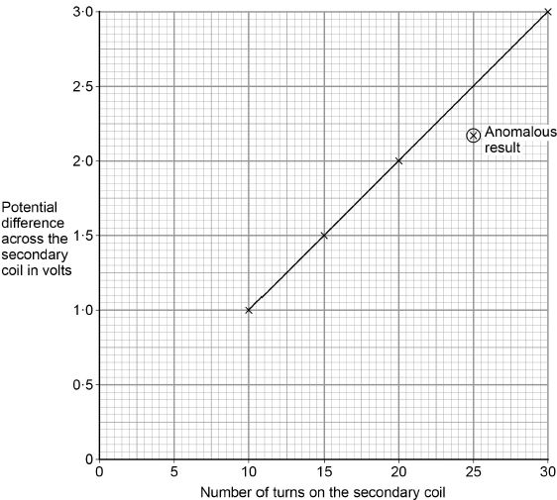

(a)  **Figure 1** contains one anomalous result.

Suggest **one** possible reason why this anomalous result occurred.

___________________________________________________________________

___________________________________________________________________

**(1)**

(b)  The transformer changes from being a step-down to a step-up transformer.

How can you tell from **Figure 1** that this happens?

___________________________________________________________________

___________________________________________________________________

___________________________________________________________________

**(1)**

A spot-welder is a device that uses a transformer to produce a large current to join sheets of metal together.

**Figure 2** shows a transformer demonstrating how a large current can heat and join two nails together.

**Figure 2**

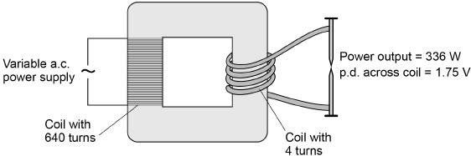

(c)  How does the amount of infrared radiation emitted by the nails change when the power supply is switched on?

___________________________________________________________________

___________________________________________________________________

**(1)**

(d)  Calculate the current from the power supply needed to provide a power output of 336 W.

Use the data in **Figure 2**.

The transformer is 100% efficient.

___________________________________________________________________

___________________________________________________________________

___________________________________________________________________

___________________________________________________________________

___________________________________________________________________

___________________________________________________________________

Current = _____________________ A

**(5)**

**(Total 8 marks)**

**Q6.**

The National Grid uses transformers to change potential difference (pd). **Figure 1** shows a transformer.

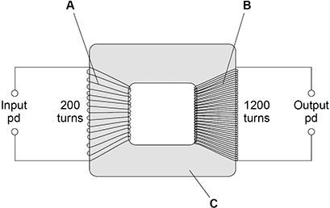

(a)  Identify the parts of the transformer labelled in **Figure 1**.

**A**  ______________________________

**B**  ______________________________

**C**  ______________________________

**(2)**

(b)  There is an alternating input pd of 230 V.

Determine the output pd.

Use the Physics Equations Sheet.

___________________________________________________________________

___________________________________________________________________

___________________________________________________________________

Output pd = __________ V

**(3)**

(c)  The input pd causes an alternating current.

Explain why there is an alternating current in the output when the transformer is connected to a circuit.

___________________________________________________________________

___________________________________________________________________

___________________________________________________________________

___________________________________________________________________

___________________________________________________________________

___________________________________________________________________

**(3)**

**Figure 2** shows a large cable supported by two wooden poles. The cable is connected to an electricity supply.

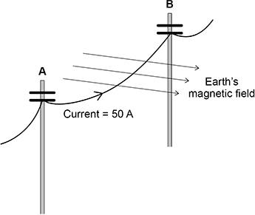

(d)  There is a force on the cable due to the Earth’s magnetic field when the current is in the direction **A** to **B**.

What is the direction of this force?

Tick (**✓**) **one** box.

|  |  |
| --- | --- |
| Down |  |
| Left |  |
| Right |  |
| Up |  |

(e)  The cable experiences a force of 0.045 N due to the Earth’s magnetic field.

magnetic flux density = 60 µT

current = 50 A

Calculate the length of the cable between **A** and **B**.

Use the Physics Equations Sheet.

___________________________________________________________________

___________________________________________________________________

___________________________________________________________________

___________________________________________________________________

___________________________________________________________________

___________________________________________________________________

___________________________________________________________________

___________________________________________________________________

Length = __________ m

**(4)**

(f)   State **one** assumption you made in your calculation.

___________________________________________________________________

**(1)**

**(Total 14 marks)**

**Q7.**

P-waves and S-waves are two types of seismic wave caused by earthquakes.

(a)  Which **one** of the statements about P-waves and S-waves is correct?

Tick **one** box.

|  |  |
| --- | --- |
| P-waves and S-waves are transverse. |  |
| P-waves and S-waves are longitudinal. |  |
| P-waves are transverse and S-waves are longitudinal. |  |
| P-waves are longitudinal and S-waves are transverse. |  |

**(1)**

Seismometers on the Earth’s surface record the vibrations caused by seismic waves.

**Figure 1** shows the vibration recorded by a seismometer for one P-wave.

**Figure 1**

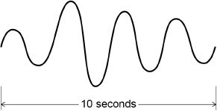

(b)  Calculate the frequency of the P-wave shown in **Figure 1**.

___________________________________________________________________

___________________________________________________________________

Frequency = _____________________ Hz

**(1)**

(c)  Write down the equation which links frequency, wavelength and wave speed.

___________________________________________________________________

**(1)**

(d)  The P-wave shown in **Figure 1** is travelling at 7200 m/s.

Calculate the wavelength of the P-wave.

___________________________________________________________________

___________________________________________________________________

___________________________________________________________________

___________________________________________________________________

Wavelength = _____________________ m

**(3)**

(e)  Explain why the study of seismic waves provides evidence for the structure of the Earth’s core.

___________________________________________________________________

___________________________________________________________________

___________________________________________________________________

___________________________________________________________________

___________________________________________________________________

**(2)**

**Figure 2** shows a simple seismometer made by a student.

**Figure 2**

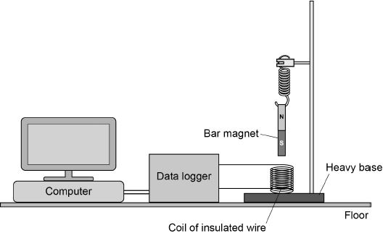

To test that the seismometer works, the student pushes the bar magnet into the coil and then releases the bar magnet.

(f)  Why does the movement of the bar magnet induce a potential difference across the coil?

___________________________________________________________________

___________________________________________________________________

**(1)**

(g)  Why is the induced potential difference across the coil alternating?

___________________________________________________________________

___________________________________________________________________

**(1)**

(h)  **Figure 3** shows how the potential difference induced across the coil varies after the bar magnet has been released.

**Figure 3**

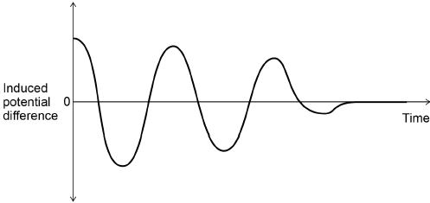

Which statement describes the movement of the magnet when the induced potential difference is zero?

Tick **one** box.

|  |  |
| --- | --- |
| Accelerating upwards. |  |
| Constant speed upwards. |  |
| Decelerating downwards. |  |
| Stationary. |  |

**(1)**

(i)   The seismometer cannot detect small vibrations.

Suggest **two** changes to the design of the seismometer that would make it more sensitive to small vibrations.

1. _________________________________________________________________

___________________________________________________________________

2. _________________________________________________________________

___________________________________________________________________

**(2)**

**(Total 13 marks)**

**Q8.**

The diagram shows a ‘G-machine’. The G-machine is used in astronaut training.

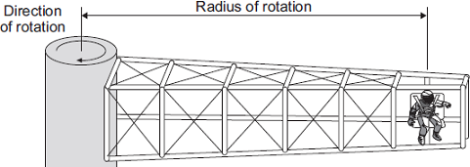

The G-machine moves the astronaut in a horizontal circle.

(a)     The force causing the astronaut to move in a circle is measured.

The graph shows how the speed of the astronaut affects the force causing the astronaut to move in a circle for two different G-machines.

The radius of rotation of the astronaut is different for each G-machine.

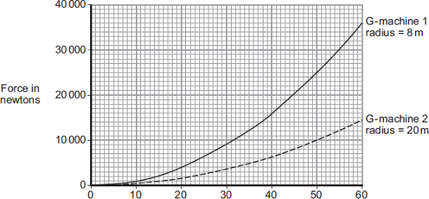

Speed in metres per second

(i)      State **three** conclusions that can be made from the graph.

1. ____________________________________________________________

______________________________________________________________

2. ____________________________________________________________

______________________________________________________________

3. ____________________________________________________________

______________________________________________________________

**(3)**

(ii)     The speed of rotation of G-machine 1 is increased from 20 m/s to 40 m/s.

Determine the change in force on the astronaut.

______________________________________________________________

Change in force = ______________________________ N

**(1)**

(b)     Each G-machine is rotated by an electric motor. The diagram shows a simple electric motor.

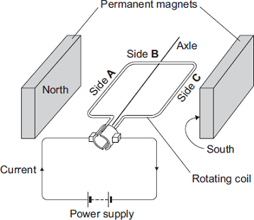

(i)      A current flows through the coil of the motor.

Explain why side **A** of the coil experiences a force.

______________________________________________________________

______________________________________________________________

______________________________________________________________

______________________________________________________________

**(2)**

(ii)     Draw arrows on the diagram to show the direction of the forces acting on side **A** of the coil and side **C** of the coil.

**(1)**

(iii)     When horizontal, side **B** experiences no force.

Give the reason why.

______________________________________________________________

______________________________________________________________

**(1)**

(c)     While a G-machine is rotating, the operators want to increase its speed.

What can the operators do to make the G-machine rotate faster?

___________________________________________________________________

___________________________________________________________________

**(1)**

(d)     The exploration of space has cost a lot of money.

Do you think spending lots of money on space exploration has been a good thing?

Draw a ring around your answer.

|  |  |
| --- | --- |
| **Yes** | **No** |

Give a reason for your answer.

___________________________________________________________________

___________________________________________________________________

**(1)**

**(Total 10 marks)**

Mark schemes

**Q1.**

(a)  current

*allow charge flow*

**or**

potential difference

**1**

(b)

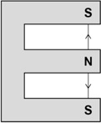

**1**

(c)  an induced magnet is a material that becomes a magnet when it is placed in a magnetic field

*allow 'when close to another magnet' for 'when it is placed in a magnetic field'*

**or**

an induced magnet loses most / all of its magnetism (quickly) when removed from a magnetic field

*allow 'no magnets are nearby' for 'removed from a magnetic field'*

*'temporary magnet' alone is insufficient*

**1**

(d)  motor effect

**1**

(e)  16 mA = 0.016 A

*allow 1.6 × 10-2 (A)*

**1**

0.013 = *B* × 0.016 × 6.5

*allow correct substitution using incorrectly / not converted current*

**1**



*allow correct re-arrangement using incorrectly / not converted current*

**1**

*B* = 0.125 (T)

*allow correct calculation using incorrectly / not converted current*

*allow 0.13 (T)*

**1**

(f)   **Level 2**: Scientifically relevant features are identified; the way(s) in which they are similar / different is made clear and (where appropriate) the magnitude of the similarity / difference is noted.

**3-4**

**Level 1**: Relevant features are identified and differences noted.

**1-2**

**No relevant content**

**0**

**Indicative content:**

•   for all three people, the minimum sound level that can be heard increases as frequency increases

**Age**

•   the minimum sound level that can be heard increases with age

•   between 2000 and 3000 Hz the minimum sound level that can be heard increases more in **B** compared to **C**

•   **C** has very little variation in the minimum sound level that can be heard at all frequencies

**Working in a loud environment:**

•   increases the minimum sound level that can be heard at all frequencies above 2000 Hz compared to working in a quiet environment

•   the minimum sound level that can be heard increases more as frequency increases from 2000 to 4000 Hz compared to working in a quiet environment

•   doesn't affect the minimum sound level that can be heard at 2000 Hz

to access **level 2** the answer must include at least **one** comparison for age **and one** comparison for working in a loud environment, using supporting data/information from the graph

**[12]**

**Q2.**

(a)  iron

*allow nickel / cobalt*

*do not allow steel*

**1**

it is easily magnetised (and demagnetised)

*allow it is a magnetic material*

**1**

*MP 2 is dependent on MP 1*

(b)  

**1**



*subsequent marks can only be awarded if the first equation is correct and has been used*

**1**

*V*s = 4.6 (V)

**1**

*V*s = 4.6 × *I*s = 6.9

*this mark may be awarded if the pd is incorrectly calculated*

**1**

*I*s = 1.5 A

*allow a correctly calculated Is using an incorrectly calculated pd*

**1**

**OR**

6.9 = *I*p × 230 (1)



*subsequent marks can only be awarded if the first equation is correct and has been used*

*I*p = 0.03 (A) (1)



*this mark may be awarded if Ip is incorrectly calculated*

*I*s = 1.5 (A) (1)

*allow a correctly calculated Is using an incorrectly calculated Ip*

**1**

**[7]**

**Q3.**

(a)  hold thumb first finger and second finger (of left hand) at right angles to each other

*allow first two fingers/index and middle for first and second finger throughout*

**1**

second finger represents the current pointing out of the paper

**1**

first finger represents the field pointing downwards

**1**

thumb points in the direction of the force / thrust / acceleration

**1**

(therefore) the rod moves left to right

*allow correct description (eg away from the magnet) dependent on scoring marking point 3 or 4*

**1**

(b)  decrease the resistance of the variable resistor

*allow increase the current/pd*

**1**

use a stronger magnet

*allow use a magnet with a greater flux density*

**1**

(c)  F = 0.30 × 1.7 × 0.050

**1**

F = 0.0255 (N)

**1**

m = 0.004(0 kg)

**1**

0.0255 = 0.0040 × a

*this mark may be awarded if m is incorrectly / not converted and / or F is incorrectly calculated*

**1**

a = 0.0255 / 0.0040

**or**

a = 6.375

*this mark may be awarded if m is incorrectly / not converted and / or F is incorrectly calculated*

**1**

*Δv* = 6.375 × 0.15 = 0.95625 (m/s)

*allow a correct calculation using an incorrectly / not converted m and / or an incorrectly calculated F*

*allow 0.96* ***or*** *0.956 (m/s)*

**1**

alternative method

*F* = 0.30 × 1.7 × 0.050 (1)

*F* = 0.0255 (N) (1)

m = 0.004(0 kg) (1)



*this mark may be awarded if m is incorrectly / not converted and / or F is incorrectly calculated*

**

*this mark may be awarded if m is incorrectly / not converted and / or F is incorrectly calculated*

*Δv* = 0.95625 (m/s) (1)

*allow a correct calculation using an incorrectly / not converted m and / or an incorrectly calculated F*

*allow 0.96* ***or*** *0.956 (m/s)*

**[13]**

**Q4.**

(a)  field lines going in, (through) and out of the solenoid

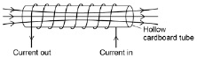

*allow field lines only visible outside the cardboard tube*

*allow a bar magnet shaped field with lines above and below the solenoid*

**1**

arrow(s) in correct direction

**1**

(b)  the rods become (induced) magnets

*allow the rods are (temporarily) magnetised*

*ignore rods repel*

*do* ***not*** *accept rods become charged*

**1**

with the same polarity (at each end)

**1**

(c)  changed two (independent) variables (at the same time)

*allow need to keep current or number of turns constant*

*allow should only change one variable (at a time)*

*allow current and number of turns both changed*

*ignore fair test*

**1**

so it is not possible to know the effect of one (independent) variable or the other

**1**

(d)  (increasing the current) increases the strength until the strength reaches a maximum value

*allow weight (held) for strength of electromagnet*

*ignore a given current value for when maximum strength happens*

**1**

(e)  increasing the number of turns from 10 to 20 increases the strength more than increasing from 20 to 30

*a general trend is required*

**1**

**[8]**

**Q5.**

(a)  any **one** from:

•   too few turns / coils on the secondary

*allow number of turns / coils on the primary was increased*

•   p.d. across the primary was reduced

*ignore human error*

**1**

(b)  the p.d. (across the secondary) goes above 2V

*allow p.d. across secondary is higher than p.d. across primary after 20 turns*

**1**

(c)  it increases (until the nails reach a constant temperature)

**1**

(d)  

**1**



**1**

Vp = 280 (V)

**1**

280 × Ip = 336

*allow their calculated*

*Vp × Ip = 336*

**1**

Ip = 1.2 (A)

*allow an answer that is consistent with their calculated value of Vp*

**1**

**or**

336 = Is × 1.75 (1)



Is = 192 (A) (1)



*allow*

**

Ip = 1.2 (A) (1)

*allow an answer that is consistent with their calculated value of Is*

*an answer of 1.2 (A) scores* ***5*** *marks*

**[8]**

**Q6.**

(a)  **A** primary coil

**and**

**B** secondary coil

**1**

**C** iron core

**1**

(b)  

**1**



**1**

*V*s = 1380 (V)

**1**

(c)  (the alternating current causes) a changing magnetic field around the primary (coil)

**1**

creates magnetic field that changes direction in the core

*allow creates a changing magnetic field in the core*

**1**

this induces an alternating potential difference across the secondary (coil (causing an alternating current)

**1**

(d)  down

**1**

(e)  *B* = 60 × 10−6 T

**1**

0.045 = 60 × 10−6 × 50 × *l*

*allow correct substitution of incorrectly / not converted value of B*

**1**



*allow correct rearrangement using an incorrectly / not converted value of B*

**1**

*l* = 15 (m)

*allow a correct calculation using an incorrectly / not converted value of B*

**1**

(e)  the wire / force is at right angles to the magnetic field

*allow the current is constant*

*allow the cable is straight*

*allow the field is uniform*

*allow the force is constant*

**1**

**[14]**

**Q7.**

(a)  P-waves are longitudinal and

S-waves are transverse

**1**

(b)  0.4

**1**

(c)  wave speed = frequency × wavelength

*allow v = f λ*

**1**

(d)  7200 = 0.4 × wavelength

**1**



**1**

wavelength = 18 000 (m)

*allow up to full marks for ecf using their answer to part* ***(b)***

*a method shown as*

*7200 × 2.5 = 18 000*

*scores* ***0*** *marks*

**1**

*an answer 18 000 scores* ***3*** *marks*

(e)  because S-waves cannot travel through a liquid

**1**

and S-waves do not travel through the (outer) core

*allow some (seismic) waves cannot travel through a liquid and do not go through the core for* ***1*** *mark*

**1**

(f)  magnetic field around the coil changes

**or**

the magnetic field (lines) cut by the coil

*allow the generator effect*

**1**

(g)  because the magnet changes direction

**1**

(h)  stationary

**1**

(i)   any **two** from:

•   stronger magnetic field

*allow stronger magnet*

*allow heavier magnet*

*bigger magnet is insufficient*

•   more turns on the coil

*bigger coil is insufficient*

*do* ***not*** *accept more coils of wire*

•   turns pushed closer together

•   spring with a lower spring constant

*allow less stiff spring*

*allow weaker spring*

*do* ***not*** *accept add an iron core*

**2**

**[13]**

**Q8.**

(a)     (i)      the greater the speed (of a centrifuge), the greater the force

*answers must be comparative*

*accept velocity for speed*

*accept positive correlation between speed and force*

*speed and force are not proportional – treat as neutral*

**1**

the smaller the radius, the greater the force (at a given speed)

*allow* ***(G machine) 1*** *has / produces a greater force (than*

***G machine 2*** *) at the same speed*

*must be comparative, eg a small radius produces a large force = 0 marks on own*

**1**

as the speed increases the rate of change in force increases

*accept force is proportional to the square of the speed*

***or***

*doubling speed, quadruples the force*

*accept any clearly correct conclusion*

**1**

(ii)      12000 (N)

**or**

12 k(N)

**1**

(b)     (i)       the current (in the coil) creates a magnetic field (around the coil)

*accept the coil is an electromagnet*

**1**

so the magnetic field of the coil interacts with the (permanent) magnetic field of the magnets (producing a force)

*accept the two magnetic fields interact (producing a force)*

*if no marks scored an answer in terms of current is perpendicular to the (permanent) magnetic field is worth max* ***1*** *mark*

**1**

(ii)     vertically downwards arrow on side A

*one arrow insufficient*

**and**

vertically upwards arrow on side C

**1**

(iii)    the current is parallel to the magnetic field

*allow the current and magnetic field are in the same direction*

*allow it / the wire is parallel to the magnetic field*

**1**

(c)      increase the current / p.d. (of the coil)

*accept decrease resistance*

*accept voltage for p.d.*

*accept increase strength of magnetic field / electromagnet*

**1**

(d)     yes with suitable reason  
**or**no with suitable reason

***eg***

***yes*** *– it has increased our knowledge*

***yes*** *– It has led to more (rapid) developments / discoveries (in technology / materials / transport) accept specific examples*

***no*** *– the money would have been better spent elsewhere on such things as hospitals (must quote where, other things not enough)*

***no*** *mark for just* ***yes*** */* ***no***

*reason must match* ***yes*** */* ***no***

**1**

**[10]**